

Breakfast Club
After School Club
Holiday Club


Hello and welcome to W.A.S.P.S.

W.A.S.P.S. (Wheathampstead After School Play Scheme) the first community based after school childcare facility in Wheathampstead.

Founded in 1992 and still going strong today, we offer good quality, safe and affordable ‘wrap around’ child care to the families and children in our village, with a Breakfast club, After School club and Holiday club.

Based at Beech Hyde Primary School and Nursery we are an independent non-profit making community organisation, employing qualified and experienced staff to care for your most precious possession, your children.

The children are at the centre of our work at W.A.S.P.S. We work hard to provide a happy, stimulating, safe and warm environment for all children to play, learn and develop freely, also giving them the opportunity to take part in decision making and planning activities.

I am proud of our organisation and the good reputation we have. I have a strong and consistent staff team who work to the highest standards working to provide good, reliable and affordable childcare; giving you the peace of mind that your children are happy and safe in our care and above all are having fun.

I hope you find this booklet informative and useful and I look forward to meeting you and your children in the future.

Thank you.
Helen Archer

Wasps Mission Statement

Wasps aim to:

- Provide a happy, safe, warm and stimulating environment for all children to play, learn and develop freely.

- Help children to develop responsibility for themselves and their actions and to become competent, confident, independent and cooperative individuals.

- Encourage children to have a positive attitude and respect for both themselves and other people.

- Promote a positive relationship with parents/carers and work in partnership with them to provide high quality play and care for their children.

- Offer inclusive services that are accessible to all children in the community.

- Undergo regular monitoring and evaluation of our services to ensure that Wasps continues to meet the needs of children and parents/carers.

Wasps are committed to meeting the needs of parents and carers by:

- Listening and responding to your views and concerns

- Keeping you informed of our policies and procedures, including opening times, fees and charges, and programme of events.

- Sharing and discussing your child’s achievements, experiences, progress and friendships, along with any difficulties that may arise.

Wasps are committed to provide:

- Excellent quality childcare that puts the needs and safety of children first.

- A programme of activities that are interesting, stimulating and above all fun.

- Activities that promote each child’s social, physical, moral, and intellectual development.

- Access to a variety of facilities and equipment under safe and supervised conditions.

- A staff team that is experienced, well trained and properly supported.

- Services that meet the conditions of the Children’s Act 2014, the Early Years Foundation Stage and all other relevant childcare legislation, wherever they apply.

- An environment where no child is bullied or suffers discrimination in any form.

Staffing

Wasps are committed to placing the best interests of children’s welfare, care and development at the centre of all staffing matters.

Staff are Wasps most valuable resource, as it is only through their commitment and effort that good quality provision can be both established and maintained. Wasps are therefore committed to providing good training and development opportunities for staff so that they are able to perform their roles both effectively and efficiently.

The staff working with your children are suitably qualified, have many years of experience and all have undergone full Criminal Records Bureau checks.

We are conscious of the importance of maintaining adequate staff to child ratios, ensuring the children are cared for safely and given attention and support at all times. Wasps’ works on a minimum ratio of 1:8 whilst in club.

Wasps Management Committee 2017/18

The Management Committee is made up of Wasps parent members, the club manager and lead play-workers, those representatives hold office for one year. Their roles include finance, fund raising activities and picking up supplies and resources. Meetings are held once or twice a term.
An Annual General Meeting is held each year; this is when W.A.S.P.s. invites parents to join the Management Committee.

This year’s members are:

Chairperson - Sarah Medlock
Treasurer - Graham Bainbridge
Members - Chris Brazier
Alison Woodbridge
Silke Anderson
Natasha Shone

Manager - Helen Archer
Lead Playworker - Vanessa Kenneford/Susie Wood

Wasps Staff Team





Helen Archer Vanessa Kenneford Susie Wood Tracey Monro
Manager Playleader Playleader Playworker

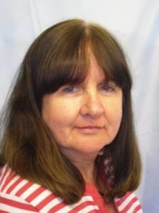
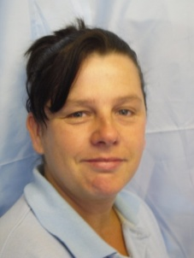

Fiona MacIntyre Eileen Pugh
Playworker Playworker

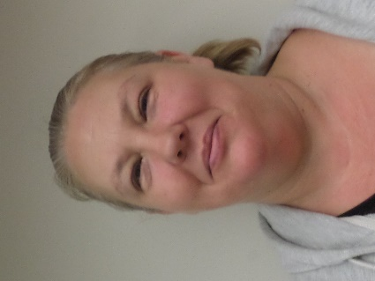
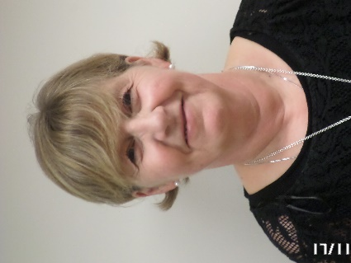

Beverley McCullough Paula Clarke
Playworker Playworker

First aid trained are: Helen Archer, Vanessa Kenneford, Susie Wood, Tracey Monro and Fiona MacIntyre.
Settling in
All children are unique and the amount of time that a child takes to settle into Wasps can vary enormously. Therefore, children will be given time to settle in at their own pace, so as to make them feel welcome, safe and confident in a new environment.

We encourage parents/carers to visit Wasps with their children before they are due to start. Children new to the club will be greeted in a warm and friendly manner. They will be introduced to all members of staff and told about any regular visitors. Parents/Carers will have the option of being part of the induction process if they so wish. Those children who are new to school and are entering the Early Years Foundation Stage will be assigned a Key Worker.

Children will be informed about Wasps routines and the programme of activities. They will be shown around, told where they can and cannot go, and have both registration and signing in/out procedures explained to them, and all other emergency procedures made clear to them.

On their first day, children will be introduced to the other children. We will allocate a ‘buddy’ who, under the supervision of a member of staff, will show your child around. All new children will be monitored by staff to ensure that they are happy in their new surroundings.

Staff will always be available to discuss any concerns or other issues with parents/carers regarding their child and their attendance at Wasps.

Arrivals and Departures
Wasps will give a warm and friendly welcome to each child on arrival and ensure that they depart safely at the end of each session.

After School and Holiday Club
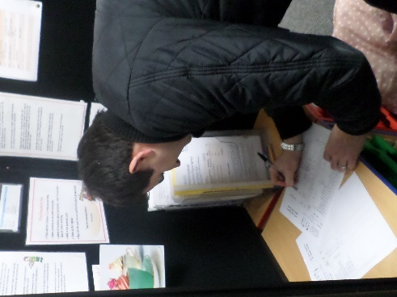
On arrival we will record your child’s attendance in the daily register. This register must be signed and the collection time logged by the parent/carer when collecting children at the end of the session. Staff must be informed if your child is to be collected by someone other than the parent/carer. If you or your nominated adult is unable to collect your child we will use a password system to identify the collector. Only adults – aged 16 years and over – and with suitable identification and password, will be authorised to collect children. No child will be allowed to leave Wasps unaccompanied. In the event that someone else should arrive to collect your child without Wasps prior knowledge we will telephone the parent or carer immediately. If you or your nominated adult collector is going to be late it is your responsibility to notify Wasps. If Wasps has no prior warning of late collection, the provisions of the Uncollected Children policy will be activated.

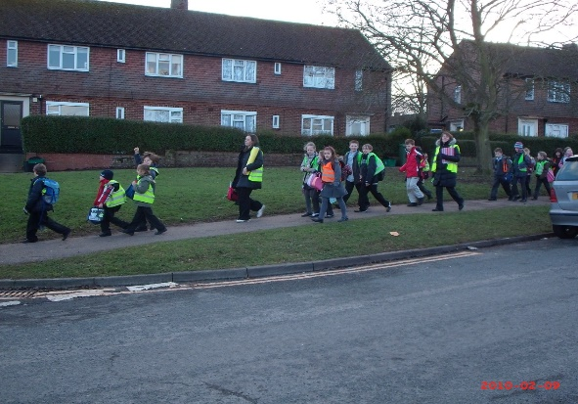
Escorting children between school and Wasps

Children will be met in the Dining room at school by Wasps staff; they will have a register of all children expected that day. It is your responsibility to inform Wasps staff of absence and cancellations.

Absences

If your child is going to be absent from Wasps you must notify us in advance. Wasps’ staff will not accept the word of other children if the whereabouts of a child is not clear, staff will immediately investigate, firstly with the child’s teacher or school office. If the child cannot be located staff will contact Wasps Manager who will then contact you. Wasps’ staff will not leave school until all children are accounted for.

Breakfast Club

Children may be dropped off at Breakfast Club, held in Beech Hyde School dining room, from 7.30am; on arrival we will record your child’s attendance in a daily register.

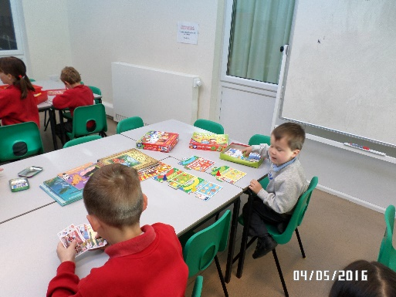
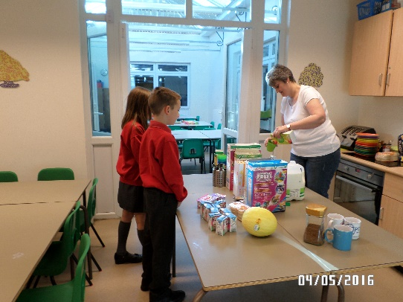
They will be offered a varied breakfast menu including cereals, toast, fruit and yoghurts. Breakfast is served until 8.15am, this allows staff enough time to clean and vacate the kitchen before the school staff arrive.

When breakfast is finished there will be opportunities for the children to take part in table top activities before school starts.

At approximately 8.30am children who attend St Helen’s School will be escorted to their school. Wasps’ staff will relinquish the care of those children to St Helen’s School staff, who will sign our register accepting responsibility for them.

Children who attend Beech Hyde School will be escorted to their classrooms at 8.50am where school staff will sign our register accepting responsibility for them.

Care, Learning and Play

Wasps aim to encourage confidence, independence and enjoyment with a varied programme of activities. Enabling children to develop their emotional, social, cognitive, interpersonal and physical skills, and their desire to explore, discover and to be creative.
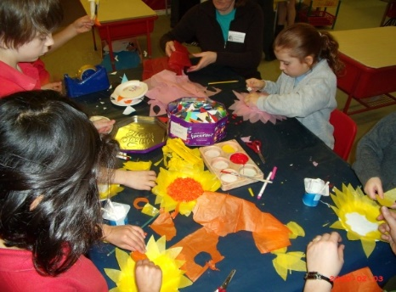
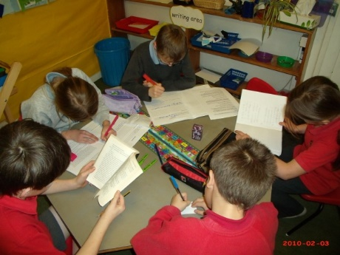
Wasps offer well planned activities in an organised environment that offers children rich and stimulating experiences, alongside opportunities to explore, experiment, plan and make decisions for themselves. Activities will recognise and take into account the differing ages, backgrounds, interests and abilities of the children. All activities will build on children’s natural curiosity, advance their thinking, use their imagination and develop positive social relationships. Staff will recognise and praise children’s efforts and achievements.
Homework tables are available for children to complete assignments.
Staff are happy to assist younger children with homework tasks from 5.15pm each afternoon.

Involving and consulting children

Wasps are committed to the principle of involving and consulting children whenever decisions are made within the club that affects them. This helps children to develop new skills such as negotiating, sharing and understanding the perspectives of others. Their involvement reflects their opinions and the children feel some ownership over the club. Wasps Kid’s Committee is elected each term.

Special needs (a full copy of Wasps Equality Policy and Inclusion Policy is available on request)

Wasps are aware that some children have special educational needs and / or physical disabilities that require particular support and assistance. We are committed to taking appropriate action to make sure that all children are able to access our services, made to feel welcome, and that our activities promote their welfare and development.

Behaviour management (a full copy of Wasps Behaviour Management Policy is available on request)

Wasps recognise the importance of positive and effective behaviour management strategies in promoting children’s welfare, learning and enjoyment. Our aims are to help children to:

- Develop a sense of caring and respect for one another
- Build caring and cooperative relationships with other children and adults
- Develop a range of social skills and help them learn what constitutes acceptable behaviour
- Develop confidence, self discipline and self esteem in an atmosphere of mutual respect and encouragement.

Bullying (a full copy of Wasps Anti-bullying policy is available on request)

Wasps are committed to providing an environment for children that is safe, welcoming and free from bullying. Bullying of any form is unacceptable and will be dealt with following Wasps procedures.

Health, Illness and Emergency (a full copy of Wasps Health and Safety Policy is available on request).

Wasps have a 48 hour exclusion period for children who have suffered with diarrhoea or vomiting. If your child is taken ill at Wasps, we will contact you or your nominated emergency contacts to come and collect them. It is important that your nominated contacts accept this responsibility by signing your Admissions form.
All members will be asked to complete the Emergency Medical Treatment form; this will enable staff to give permission for emergency medical treatment for children in the event of a major accident, incident or illness occurring at Wasps.

Medication

Wherever possible, children who are prescribed medication should receive their doses at home. If it is necessary for medication to be taken at Wasps, parents or carers must complete and sign the Administering Medication form.

Sun protection

In hot weather it is your responsibility to provide sun cream and sun hats for your children. Staff will encourage children to apply sun cream themselves. Wasps’ staff will apply sun cream to those unable to do so themselves where prior permission has been given by you on the Admissions form.

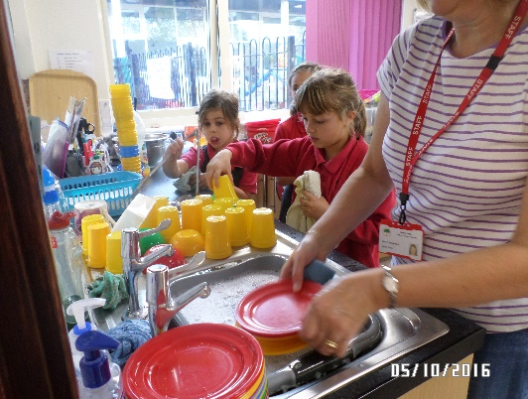
Food and drink

Wasps are committed to providing healthy and nutritious food and drinks. At after school club children will be offered a varied menu each week including pasta, rice, bread with fresh fruit and vegetables daily; and milk, squash or water to drink. At Breakfast Club children will enjoy a healthy menu including cereals, toast, fruit and yoghurt.
Staff regularly plan activities involving food preparation and tasting and will introduce children to different religious and cultural festivals and events through different types of food and drink.

Admissions

Wasps are committed to providing a fair and open admission system that offers a competitively priced and good value service.

Registration

Wasps’ registration fee is £25 per family. This is for one year with a renewal fee of £10.
If there is not a suitable place available immediately your child’s name will be added to a waiting list. If we are unable to offer you a place six months after your desired start date and you remove your child’s name from our list we will refund your registration fee.

Terms and Conditions of Membership

Allocation of places to After School Club and Breakfast club will incur a retaining fee should you not take up the place immediately, i.e. deferring your start date. This is charged at the regular amount per session i.e. £10.00 per session at ASC and £4.80 per session at BC.

After School Club (ASC)

- £10.00 per child

We offer a reduction for siblings. Fees are due a term in advance.

Regular delayed payment of fees will result in cancellation of membership.

Late collection fines ASC (please see Uncollected Children Policy page 6)

Please collect children by 6.15pm. Wasps will impose fines if collection time exceeds 6.15pm.

- Up to 15 minutes late £5.00 per child

- Up to 30 minutes late £10.00 per child

- Over 30 minutes late the Uncollected Child Policy will be activated and we will continue to add £5 per child for every 15 minutes he/she remains in our care.

Paying your fees:

Wasps accept payment by cheque, online banking or childcare vouchers available from your employer; please ask for details.

Enquiries, bookings and cancellations

Please telephone 01582 834190 or email admin@wasps-asc.org

If you need to cancel your child’s session on the day of expected attendance please phone or text your message to;
ASC - 07522 552041; HC - 01582 834190.

All other enquiries please telephone 01582 834190 or email admin@wasps-asc.org

PLEASE DO NOT LEAVE MESSAGES WITH SCHOOL STAFF OR ASK CHILDREN TO GIVE MESSAGES.

Occasionally, the schools inset days do not coincide; Wasps ASC will open on these days if there are bookings of at least 16 children. Wasps will try and give a minimum of 2 weeks’ notice of closure, however this does not include emergency closure i.e. in the event power failure or school closure for any reason.

To terminate your membership or give up places or amend your child’s sessions please give 4 weeks’ notice in writing. In absence of this unfortunately there will be a charge equal to the 4 weeks sessions.

Holiday Club (HC)

Holiday provision is:

- Whole day; 8.30am to 5.30pm @ £23 per child member or £25 for non-members.

- Half day: 8.30am to 12.30pm OR 1.30pm to 5.30pm @ £15 per child member or £17 for non-members.

Booking HC

Holiday Club dates will be sent out to all members at the beginning of each term.

Completed booking forms and payment should be returned to Wasps by the closing date. Places will be awarded on a first come first served basis.

Please collect children by the pre-booked time i.e. 12.30pm or 5.30pm.
Fines will be imposed for late collection (see late collection fines ASC above and Uncollected Children Policy page 6).

Breakfast Club (BC)

Provision is from 7.30am until school opens

- £4.80 per child per session

Fees are charged in advance at the beginning of each term. Regular delayed payment of fees will result in cancellation of membership.
Cancelled sessions or absenteeism will be charged.
Please telephone 01582 834190 for enquiries and bookings and phone/text cancellations on 07522 552041.
Uncollected children policy (ASC & HC)

Wasps have the highest regard for the safety of your children, from the moment they arrive to the moment they leave.

At the end of every session, Wasps will ensure that all children are collected by a parent, carer or designated adult. If for some reason a child is not collected at the end of a session, Wasps are obliged to follow the procedures as set down by Ofsted:

- If you are more than 15 minutes late, staff will call you or your designated adults, and use any other emergency contact details given on your Admissions form in order to try and ascertain the cause for the delay, and how long it is likely to last. Messages will always be left on any answer phone requesting a prompt reply.

- While waiting your child will be supervised by at least two members of staff who will offer them support and reassurance.

- If, after repeated attempts, no contact is made with you or your designated adults, and a further 30 minutes has elapsed, we will call the local social services department for advice.

- In the event of a child being passed to a child protection agency, we will attempt to leave a further telephone message and a note will be left on the door at Wasps informing you of what has happened.

- Under no circumstances will a child be taken to the home of a member of staff.

- Incidents of late collection will be recorded and persistent late collection will result in cancellation of membership.

Child protection (a full copy of Wasps Safeguarding Children Policy is available on request)

Wasps believe that children have the right to be completely secure from both the fear and reality of abuse, and we are committed to protecting all the children in our care from harm. Wasps are committed to ensuring that it meets it responsibilities in respect of child protection by treating any allegation seriously and sensitively. Wasps will not carry out any investigation itself into a suspected child abuse incident. On discovering an allegation of abuse the Child Protection Officer will immediately refer the case to the local statutory child protection agencies.

Complaints procedure

Wasps are committed to providing a safe, stimulating, consistent and accessible service to children and their parents / carers. We always aim to provide high quality services for everyone, but accept that sometimes things do not always go to plan. In such circumstances, we want to know so that we can put them right and learn from our mistakes.

Under normal circumstances Wasps Coordinator will be responsible for managing complaints, if a complaint concerns the Coordinator it will be referred to the Management Committee who will be involved in investigating and resolving the issue

Stage One

If you have a complaint about some aspect of the Club’s activity, or about the conduct of an individual member of staff, it will often be possible to resolve the problem by simply speaking to the individual concerned and/or the Coordinator. Wasps is committed and open to regular dialogue with parents/carers and welcomes all comments on its service, regardless of whether they are positive or negative.

In the first instance, parents/carers are encouraged to speak directly to the relevant member of staff. If this is unsatisfactory the Wasps Coordinator should be approached and she will try to resolve the problem. If a satisfactory resolution cannot be found, then Stage 2 of the procedure will formally come into operation.

Stage Two

If a satisfactory resolution has not been found, parents/carers should put their complaint in detail in writing to Wasps Coordinator. Relevant names, dates, evidence and any other important information on the nature of the complaint should be included. Wasps will acknowledge receipt of the complaint as soon as possible, and fully investigate the matter within 15 working days. If there is any delay Wasps will advise the parents/cares of this and offer an explanation. Wasps will send a full and formal response to the complaint.

If at the conclusion of this process parents/carers remain dissatisfied with the response they have received, the original complaint will be passed to the Management Committee who will review and adjudicate the case.

Wasps will advise Ofsted of all complaints made against them.
Any parent/carer can, at any time, submit a complaint to Ofsted about any aspect of the registered childcare provision. Ofsted will consider and investigate all complaints received.

Ofsted (Office for Standards In Education)

Wasps is regulated and inspected by Ofsted and a full copy of our Inspection Report can be viewed online at www.ofsted.gov.uk

Wasps’ registration number is 123642 please quote this in all correspondence to:

Ofsted Early Years telephone number 08456 40 40 40.

Thank you for your interest in our organisation. If you would like to visit Wasps ASC, HC or BC please telephone 01582 834190 to make an appointment. We look forward to meeting you and your children.

